|  |
| --- |
|  |
| Wek 07 Project |
|  |
| Motherboard Replacement |

**CIST 0161: The Technology of Computing**

October 30, 2022

Author: Jason Li

Wek 07 Project

Motherboard Replacement

Contents

Introduction 2

Procedure 2

Results 2

Conclusion 2

References 3

Wek 07 Project

Motherboard Replacement

# Introduction

**This Lab will teach you how to replace a motherboard**

# Procedure

**Delete the following:**

Describe the procedures followed for this lab. Images may be used and referenced as Figure 1, Figure 2, etc.

Example:

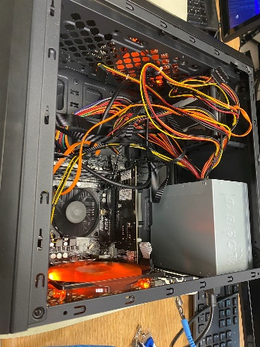  
**Figure 1: Disconnect the unit, put on ESD equipment Open up the case**

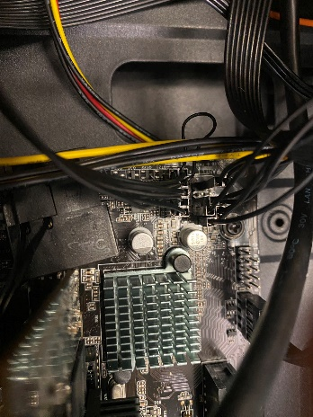

**Figure 2: Take a picture of front panel, located in bottom right of the mother. Than disconnect it.**

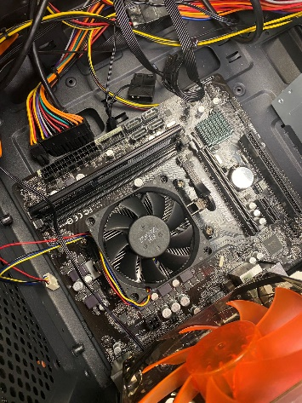

**Figure 3: Disconnect all cable and external drives connected to the motherboard. Then remove the screws that’s connected to it**

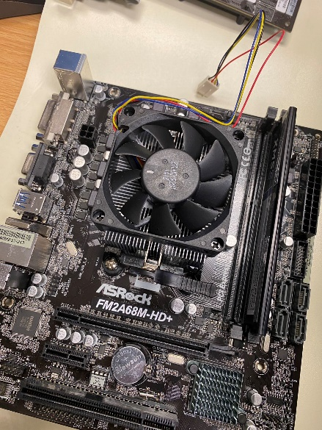

**Figure 4: Remove the motherboard from the case**

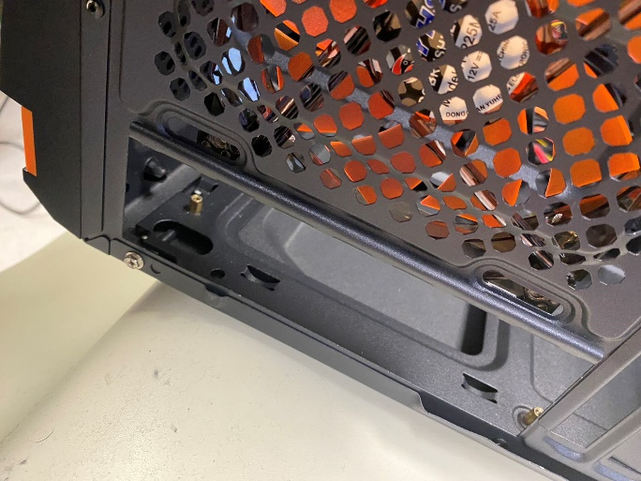

**Figure 5: Remove the side panel**

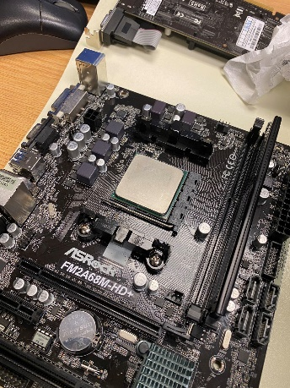

**Figure 6: Remove the CPU cooler**

**Figure 7: Remove the RAM**

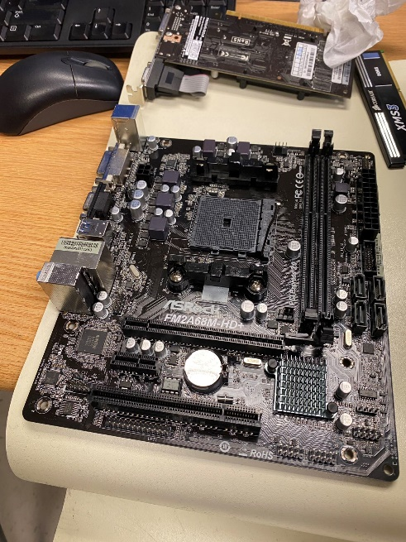

**Figure 8: Check all the things**

**Figure 9: Put back the CPU and the RAM, Apply thermal compound on CPUA picture containing text, electronics

Description automatically generated**

**Figure 10: Put back the CPU cooler**

**Figure 11: Put back the motherboard and side panel** 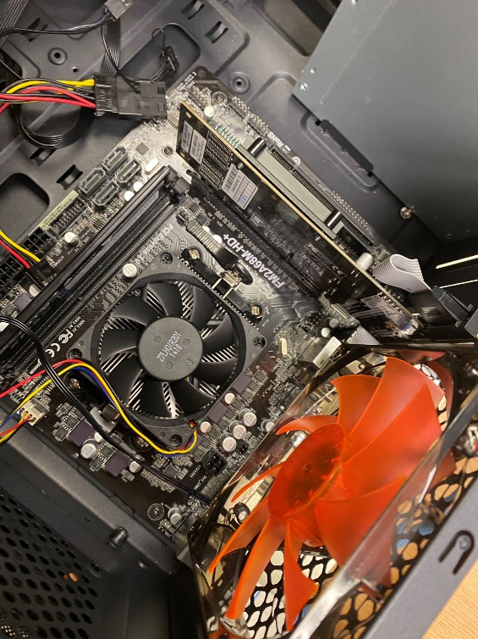

**Figure 12: Put back the screws and the GPU**

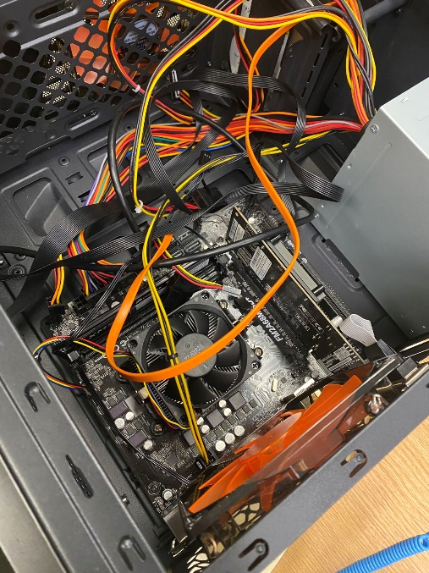

**Figure 13: Connect all the cable back and try to power on. if it works, close the case and put it back**

# Results

1. What are the purpose of standoffs?
   1. The purpose of standoffs is to create spacers that go between a motherboard and computer case to ensure that there is no contact between the circuitry of a motherboard and the case.
2. What is POST?
   1. The POST process checks computer hardware, like RAM (random access memory), hard drive, CD-ROM drive, keyboard, etc.
3. Provide a link to the motherboard manual for your motherboard.
   1. https://download.asrock.com/Manual/FM2A88M-HD%2b.pdf
4. What is the make/model of your motherboard?
   1. ASRock - FM2A88M-HD+
5. What is the socket type of your processor/motherboard?
   1. FM2+
6. What type of RAM does this motherboard utilize?
   1. Dual Channel DDR3 Memory AKA DDR3 DIMM
7. Does this processor utilize pins or lands?
   1. Pins
8. What are the components of a stock cooling system?
   1. Thermal Compounds, Heat sink, and fan
9. Identify the maximum amount of RAM supported by your motherboard.
   1. 32G
10. Does your motherboard support dual channeling or greater?  If so, what kind of channeling.
    1. Dual Channeling, DDR3 memory technology
11. Utilizing a site like newegg.com, locate compatible RAM in size and quantity to optimally fill this motherboard.  Post a link here and indicate quantity.
    1. <https://www.newegg.com/crucial-32gb-240-pin-ddr3-sdram/p/N82E16820148803?Description=32g%20ddr3&cm_re=32g_ddr3-_-20-148-803-_-Product>
    2. 16Gx2
12. Locate a compatible replacement processor on a site like newegg.com and post the link here.
    1. https://www.newegg.com/amd-athlon-x4-860k/p/N82E16819113410?Description=FM2+%2095W%20cpu&cm_re=FM2+_95W%20cpu-_-19-113-410-_-Product&quicklink=true
13. What is the maximum speed of this processor?
    1. 3.5ghz
14. How many cores does it have?
    1. 2
15. Does it support hyperthreading?
    1. No
16. Locate a compatible fan-based aftermarket cooler on a site like newegg.com and post the link here.
    1. https://www.newegg.com/rosewill-rocc-16003/p/N82E16835200114?Description=FM2+%20cooling%20fan&cm_re=FM2+_cooling%20fan-_-35-200-114-_-Product
17. Locate a compatible liquid cooler on a site like newegg.com and post the link here.
    1. https://www.newegg.com/p/1YF-01PK-00001?Item=9SIB601J6G9093&Description=fm2+%20cpu%20cooler&cm_re=fm2+_cpu%20cooler-_-9SIB601J6G9093-_-Product&cm_sp=SP-_-1392579-_-0-_-2-_-9SIB601J6G9093-_-fm2+%20cpu%20cooler-_-cooler|cpu-_-1
18. Utilizing a site like newegg.com, find the substance that is applied between the processor and heatsink and post a link here.
    1. https://www.newegg.com/arctic-silver-as5-3-5g/p/N82E16835100007?Description=thermal%20compound&cm_re=thermal_compound-_-35-100-007-_-Product
19. Why is it important to ensure the fan is operational when done with the lab?
    1. So the CPU doesn’t over heat and shutdown.

# Conclusion

**DELETE:** Describe what you have learned from this lab.